Finnish Psychologists for Social Responsibility (FiPSR) and Finnish-Arab Friendship Society (FAFS) & Beit Atfal Assumoud

Report of the project visit 20.2.-23.2.2020, participants Sirkku Kivistö, Miranda Koskinen, Riina Lepistö, Kaarle Lagerstam, psychologists, members of the Lebanon project team of FiPSR. Ms Emma Ojanen, living in Beirut, joined the program partly.
Sirkku Kivistö continued the visit until Feb 28th

Purpose of the visit
-discuss about the ongoing projects by FiPSR and FAFS (2019-2020), the results so far and adjustments in the project plan and budget for 2020
-the mental health program strategy plan
-jointly planning the continuation projects of FiPSR and FAFS for the years 2021-2024 (deadline for Foreign Ministry application is March 31st)

Visit program
*Familiarizing with the strategy and administration renewal of the mental health program of BAS
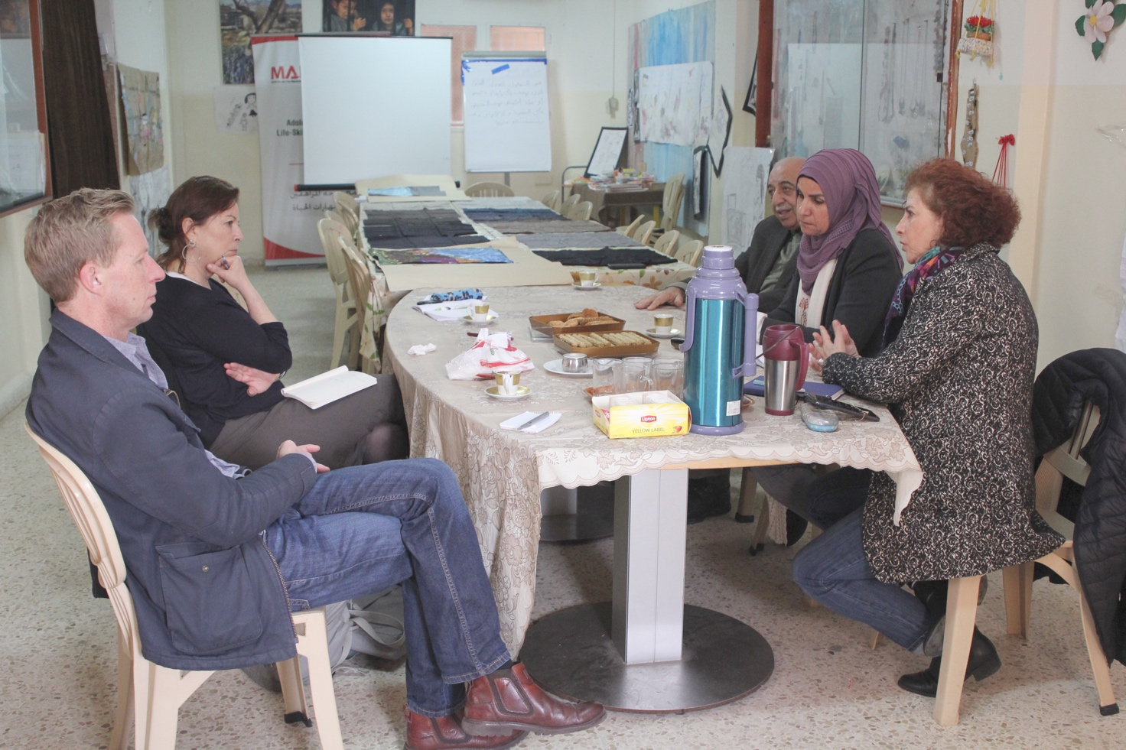
Meeting in Mar Elias center 25.2.2020 to prepare the strategy: Mr Bendik Sorvig, UNRWA, Dr Lamia El-Fattal, Director Kassem Aina, mental health program coordinator, Ms Khawla Khalaf, Dr Muna Khalidi, board of BAS.

*Reporting 2019 and planning 2021-2024
-Checking the drafts for Ministry reports about 2019 including the financial reports (audited financial reports deadline to the Finnish accountant Tuesday Feb 25th)
-Checking the drafts for continuation projects, South FiPSR, North FAFS, and the budgets
-Visit to UNRWA to learn about their capacity in health care and mental health care this year and forward (this must be explained in the project plans for 2021-2024)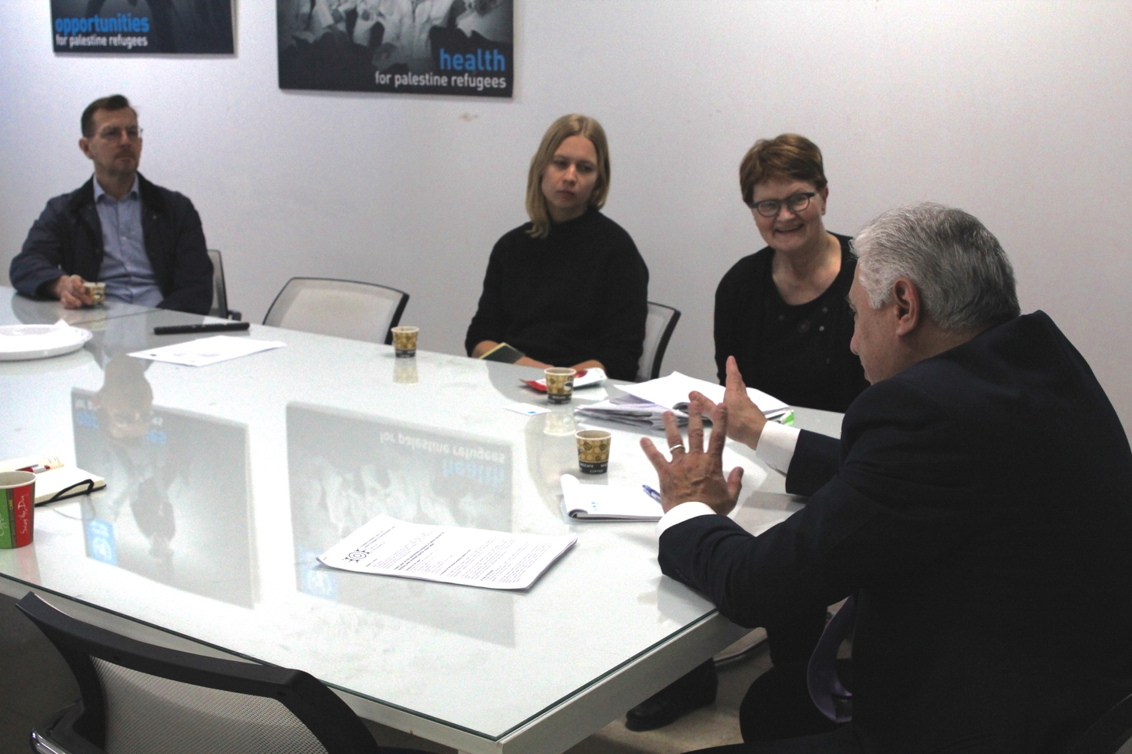
Kaarle Lagerstam, Riina Lepistö, and Sirkku Kivistö meeting with Dr. Abed Al Hakim Chanaa, Chief Field Health Programme, UNRWA, Department of Health, Lebanon Field Office 23.2.2020

*Food security campaign by FiPSR from Dec 2019 to the end of Feb 2020
Discussion about the food security extra campaign for the families with MSN-children (strengthening the disability component of the project) (donations from Dec 2019-to Feb 7th 2020 2390 €). How the delivery of extra resource for food is possible to done in practice? Would Khawla organize the deliver through her contact with FGCs?

*Site visits and meetings with sponsored children/elderly
Visits to Shatila center and Bourj el Barajneh, visits to FGCs in the South and in the North, some meetings with sponsored children/elderly
Seeing the new premises and other news of FGC Saida

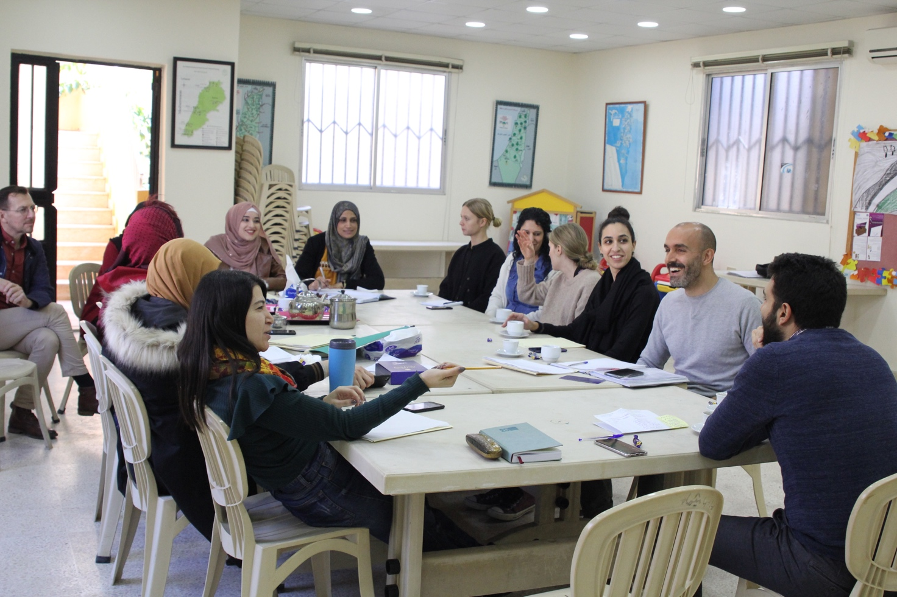
Meeting with the FGC El-Buss team 20.2.2020

*Cooperation
-Coordination meeting with Kristil Haraldstad, Norwac, Sunday morning 23rd Feb
-Meeting with Ms Emma Ojanen, living in Beirut, discussion about possibility to share the voluntary work of FiPSR for BAS
-Discussion about cooperation offers and ideas through FiPSR:
- Ms Helen Creswell, Christian Codrai Foundation, Italy, some art counseling or some training in a camp.
- Ms Noora Kivimäki and Ms Nelli Koskimäki from NGO Global Sosial Work (supporter to Shatila social work) and University of Tampere, Department of Social Work – their internship and thesis requests, with Dr Rania Mansour
- Child’s Mind -materials for Kindergartens, update of the cooperation plan with Ms Rania Khartabil
- Ms Anne Pauna – about the children with the stunted growth & Nahr el-Bared children’s clinic
- Journalist Hanna Hirvonen is preparing article about the work permissions of Palestinians in Lebanon, based on her interviews in September 2019. Any new developments in the issue?
- Preparing the Stress reduction ToT visit by Ms Nina Lyytinen.

Thu 20 | Visit of the Finnish group to South FGC El Buss – joining the meeting of FGC team, walk around the El-Buss camp
Fri 21 | Main office, meeting with Dir Kassem Aina, discussion about the strategy renewal of Bas mental health program.  Meeting with Dr. Abed Al Hakim Chanaa | Chief Field Health Programme, discussion about the health care situation in camps.  Meeting with the mental health strategy planning group: Strategy of the mental health program of BAS and promotion of the implementation.  Financial department, update of the project budgets for 2020
Sat 22 | Visit to Nahr el-Bared, discussion with FGC teams of Nahr el-Bared and FGC Beddawi concerning the mental health program in the north, which is supported by FAFS, camp walk for information of the new members of the project team
Sun 23 | The group of 3 leaves to Finland at 09:45.  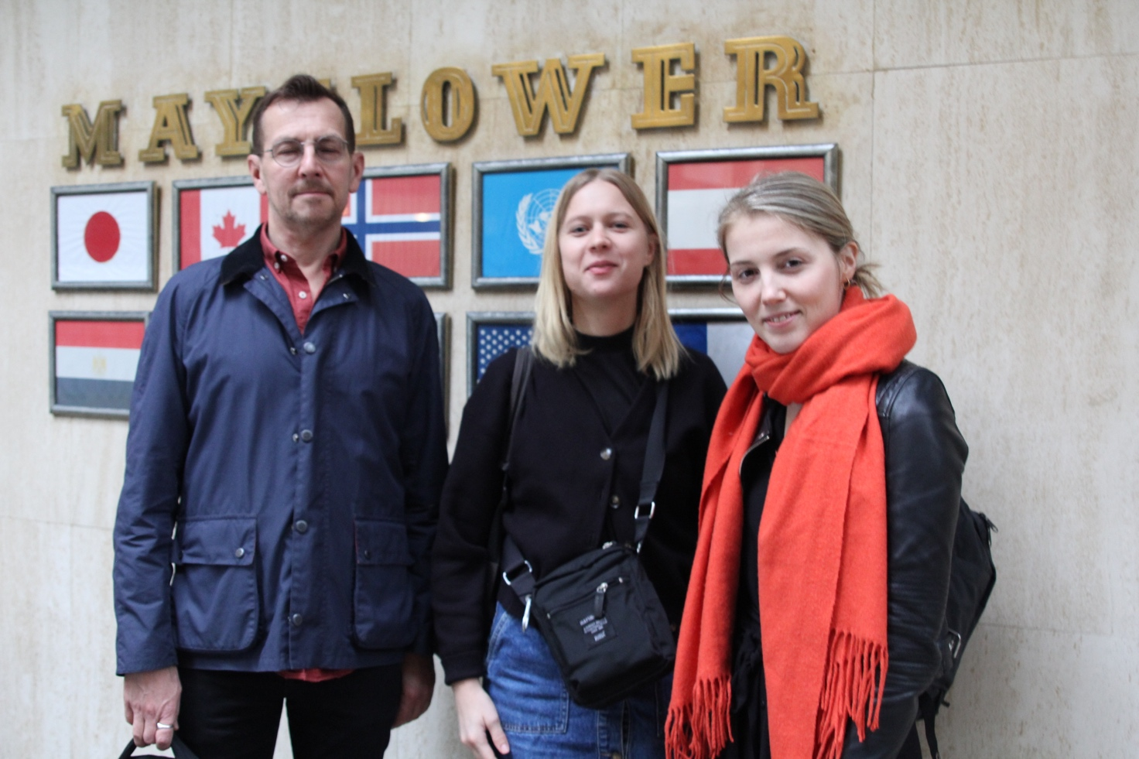  Kaarle Lagerstam, Riina Lepistö, Miranda Koskinen  Sirkku meeting with Kristil Haraldsen, NORWAC, about joint work.  Moves to Arrawas flat. Own program for the day
Mon 24 | Sirkku continues the visit, negotiations with Dir Kassem Aina, mental health program coordinator Ms Khawla Khalaff and sponsorship program coordinator Ms Fatima Khaizaran  Visit in Shatila Center
Tue 25 | Meeting in Mar Elias Center with board vice member, Dr Muna Khalidi, Dir Kassem Aina, Ms Khawla Khalaf, Mr Bendi Sorvig and consultant, Dr Lamia al Fattal . Planning the new strategy for mental healt program.
Wed 26 | Meeting in Nahr el-Bared Center, meeting with the FGC team, led by Dr Elias Abdel Sater. Meeting with social workers of Family happiness  program
Thu 27 | Closing the visit topics in the main office. Collecting materials for the continuation project plan.
Sirkku Kivistö, departure on Friday morning, February 28th to Finland

