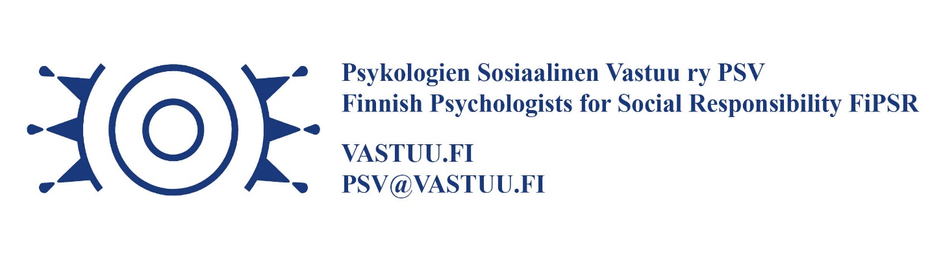
Report: Sponsorship program of special service for children with multiple special needs: overview of 40 annual progress reports of MSN children, school year 2019-20
prepared by Veera Nieminen 7/2020

______________________________________________________

Contents
A. Program’s background 2
B. School year 2019 -20: Review of the progress reports 3
C. Information about the children and their challenges 4
D. Received treatment and cooperation 5
E. Children’s current situation: how do the children benefit from the program 8

Appendix: Progress report form 10

- Program’s background

As a part of the project “Mental health for groups with complex needs: a multidisciplinary model combining client centered and community approaches (2019-2020)”, FiPSR (Finnish psychologists for social responsibility) supports a sponsorship program for children with multiple special needs. The sponsorship program provides services for disabled Palestinian children and their families in Lebanon. The local partner is BAS/NISCVT (Beit Atfal Assumoud/The National Institution of Social Care and Vocational Training). The Mental Health program of BAS/NISCTV runs five Family Guidance Centers (FGS’s) in Lebanon. Since 2009, these FGC’s have increased the service for children with multiple special needs (MSN): special education, rehabilitation and the follow-up in the FGC. In school year 2019 - 20, 154 children with multiple special needs attended the program, of which 17 supported by FiPSR’s private sponsors and sponsor groups and 12 from the project funding.
The aim of this report is to examine the situation and progress of the MSN children that attend the program. This report based on the evaluations that FGC professionals do for each sponsored child on a yearly basis.

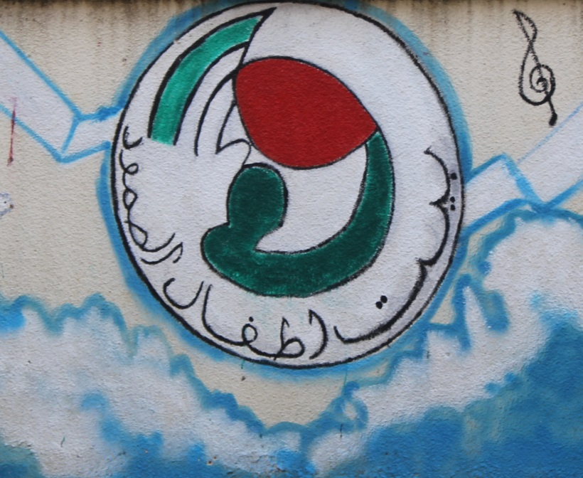
The logo of BAS (painting in BAS center in Beddawi)

- School year 2019- 20: review of the progress reports (n=40)

This review based on 40 progress reports, which is a sample of the 154 children with multiple special needs who attend Beit Atfal Assumoud’s program to receive rehabilitation for their difficulties. The rehabilitation is coordinated by the local Family Guidance Center (FGC). 50% of the children were from Beirut area, 17.5% from Saida, 12.5% from El Buss, 10% from Beddawi and 10% from Naher Bared. The progress reports were prepared by FGC social workers Hanane Dabduob, Mona Shaaban, Nivin Al Murshed, Riham Mansour, Katia Barakat, Mona al Merhi and Hala Sayed.
17 of the children were sponsored by FiPSR sponsors and sponsor groups, 12 by FiPSR project funding, 8 by Palestine’s Children Switzerland (PalCH) and 3 by Christian Codrai Foundation Italy (CCF).
The children of the sample studied in 15 special schools in which they had a possibility to receive education in a way that took into account their developmental difficulties. One child was not able to attend school, and one went to public school.
The majority of the children were age 6-11 (primary school). Two were under school age, 9 intermediate school age (12-14) and 6 were at secondary school age or older. 90% of the children were Palestinian. The majority had attended the program for several years, which is understandable considering the complex developmental difficulties they had. 7 children were new in program.
The children’s difficulties were delays in cognitive development (intellectual disabilities), learning problems, aphasia/language disorders, ADHD, epilepsy, autism/autism spectrum disorders, Down syndrome, cerebral palsy and psychological problems such as depression or anxiety. Most of the children had more than just one kind of difficulty. The rehabilitation included special education, different kind of therapies and working with the family. Sometimes the mother attended psychotherapy. 57.5% of the families attended also some other NISCVT activities, such as parent activities, family happiness sponsorship program, cultural activities, summer activities or dental care.
In the comments section it came clear that the year in Lebanon has been tough, especially for the underprivileged people. The political conflicts (demonstrations, roadblocks), economic crisis and covid-19 pandemic did have a major impact on people’s daily lives. Many lost their jobs and the lock-downs changed families’ daily routines. Children’s school year was discontinuous and the FGC’s had to be shut at times. FGC professionals did a lot of work to stay in touch with the families by remote connections. Also extra food aid money was delivered. Despite of all, in the report social workers evaluated that most of the children had achieved some progress: many made progress for example in academic skills, communication and self-expression. Also parent’s skills to deal with the child was improved in many cases.

- Information about the children and their challenges
The ages of the children
Most of the children were in primary school (57,5 %) or intermediate school (22,5 %). A few were pre-schoolers or in secondary school age. A few were young adults (over 18 years) who still received rehabilitation and support to build as independent life as possible.
AGE | NUMBER | PERCENTAGE %
Pre-school or younger | 2 | 5,0 %
Primary school age (6-11) | 23 | 57,5 %
Intermediate school age (12-14) | 9 | 22,5 %
Secondary school age (15-18) | 3 | 7,5 %
18 or older | 3 | 7,5 %

Nationality
The majority of the children were Palestinian, part of which Syrian flees. 3 children were Syrian. One child’s nationality was unknown for some reason.
 | NUMBER | PERCENTAGE %
Palestinian | 36 | 90,0 %
Syrian | 3 | 7,5 %
unknown | 1 | 2,5 %

Years in sponsorship program
Most of the children has been in the program for several years. This is understandable since most of the difficulties are quite permanent and require long-term treatment and rehabilitation. However, there were also 7 new children in the program.

 | NUMBER | PERCENTAGE %
6 years or more | 9 | 22,5 %
5 years (since 2015) | 2 | 5,0 %
4 years (since 2016) | 5 | 12,5 %
3 years (since 2017) | 12 | 30,0 %
2 years (since 2018) | 5 | 5,0 %
1 year (since 2019) | 7 | 17,5 %

Main difficulties of the children
As it appears in the name “children with multiple special needs”, the children attending in the program have complex developmental problems. In 55 % of the cases, there were more than one difficulties mentioned.
The most usual problems related to delay in cognitive development. Developmental delay or intellectual disability was mentioned in over half of the cases (52,5 %) and learning disabilities 17.5 % of the cases. Other difficulties were attention-deficit and hyperactivity disorder (15 %), epilepsy/seizures (20 %), autism or autism spectrum disorder (17.5 %), Down syndrome (12.5 %), cerebral palsy (10 %), delay in motor development (5 %) and aphasia or delay in language development (20 %). In 10 % (4 children) there was also psychological reasons mentioned (depression, anxiety, distress, repetitive behaviour). Two children (5 %) had also somatic diseases.

- Received treatment and cooperation

Needs of the children
Most of the children did need more than one form of rehabilitation. Most of the children (77.5%) attended in a special education program. Only a few (4 children) didn’t attend any therapies. 60% attended speech therapy, 50% psychomotor therapy, 42.5% psychotherapy, 17.5% physiotherapy, 15% occupational therapy and 7.5 % music therapy. Some of the treatment appointments (for example psychotherapy) were addressed for the children’s mothers. Many of the appointments were arranged in special schools, some in FGC’s. 35% of the children needed medical treatment.

Main aims of the treatment
In the reports, it was asked that what kind of improvement is wished to achieve by treatment. The aims were numerous: achieving better cognitive abilities and academic performance (reading, writing), social skills, speech/ communication skills, motor/ sensory skills, controlling own behaviour and building better self-confidence and autonomy. Rehabilitation also aimed to increase better understanding on the child’s situation and support parents and families to help the child. In general, the goals seem to aim for giving the children the chance to use their resources in the best way so that they can live as independent and normal life as possible. However, some children will need assistance throughout their life.

Special schools
For Palestinians, it is not easy to receive special education of good quality. Some schools do not accept Palestinians and the tuition fees are not affordable for the most of them. The mental health program of Beit Atfal Assumoud has succeeded to create a large network of special schools and rehabilitation centers, which accept Palestinian children. The sponsored children were studying in 15 institutions. Special school “Tanmieh Fikrieh” in Beirut was mentioned most often (8 children). Other schools were AID center (1 child), Tarbia wa Islah (1), Ghassan Kanafani Foundation (4), Saida International School – Path for Life (3), Saida Technical institute for Young Women (1), Social Care institution Ketermaya (1), Happy Home Al Beit Assaied (2), Lebanese Welfare Association for the Handicapped Nabih Berri Rehabilitation Compound (1), Al Mujad (1), Ali Hallak School (1), Mohamd Khaled Institution (1), Avance School (1), Al Mona Center (3) and Dar Al-Aytam Al-Islameya (4). One child wasn’t attending in any education. One child went to public school.
Most of the children (75%) continued studying in the same school than before in school year 2019-20. 10 children (25%) changed the school. The most usual reason for changing the school was age (there was no class for teenagers etc.). Other reasons were challenges with transportation or tuition fees or difficulties to find a suitable school or get accepted.

Consultations with a psychiatrist
It was most usual (43.6 % of the children) to have one psychiatrists’ consultation during the school year 2019-20. It was also quite common to have 2 or 3 consultations. Two children did not have any consultations. A bunch of children needed more consultations.
 | NUMBER | PERCENTAGE %
0 | 2 | 5 %
1 | 17 | 42.5 %
2 | 9 | 22.5 %
3 | 6 | 15 %
4 | 2 | 5 %
5 | 1 | 2.5 %
7 | 1 | 2.5 %
10 | 1 | 2.5 %
12 | 1 | 2.5 %

Sessions with other specialists
The number of sessions with other specialists (psychologists, psychomotor therapists, speech therapist, physiotherapists, social workers, occupational therapists) were reported in varying manners, which is why this information is hard to compare. Some sessions were for children, some for mothers. In some cases (7 children, 17.5 %), it was mentioned that the sessions located in school and therefore the exact number was not known. According to the reports, at least 25% of the children received intensive (at least once a week, at least one kind of rehabilitation) sessions in FGC’s. At least 6 children (15%) had appointments about once a month. 2 children (5%) had one session during the school year and 1 child (2.5%) had 2 appointments. In 5 children’s reports it was mentioned that there was no sessions in FGC during the school year. 6 children (15%) lacked the information. It was also mentioned that political riots, roadblocks and covid-19 pandemic affected on therapy sessions. In such periods, the specialists kept in touch with families by phone calls or WhatsApp.

Number of home visits
Each child in the program received at least one home visit by social worker. Home visits are an effective way to gain understanding on child’s home and living conditions.
For 32.5% of the children there was one visit, and for 45% 2-4 visits during the year. 12.5% of the children’s families received 5-9 visits and 10% ten or more visits.
 | NUMBER | %
1 visit | 13 | 32.5 %
2-4 visits | 18 | 45 %
5-9 visits | 5 | 12.5 %
10-15 visits | 4 | 10 %

Perceived cooperation
In the annual progress reports, the quality of cooperation is estimated. Mostly the experiences were positive, especially between families and FGC’s. In terms of the progress of the child, it is important that actors are able to work in cooperation for child’s good.

Cooperation between FGC & school
 | NUMBER | %
Very good | 18 | 46.2 %
Good | 13 | 33.3 %
Fair | 8 | 20.5 %
N=39, one child is not attending school
Cooperation between FGC & family
 | NUMBER | %
Very good | 33 | 82.5 %
Good | 7 | 17.5 %
Fair | 0

Cooperation between family & school
 | NUMBER | %
Very good | 16 | 41.0 %
Good | 17 | 43.6 %
Fair | 6 | 15.4 %
N=39, one child is not attending school

- Children’s current situation: how do the children benefit from the program

Progress of the child (assessed by the FGC team)
12.5% of the children made very good improvement and 65% good improvement. In 22.5% of the cases the improvement was assessed to be fair.
 | NUMBER | %
Very good improvement | 5 | 12.5 %
Good improvement | 26 | 65 %
Fair improvement | 9 | 22.5 %

Need for continuation
In all of the cases, social worker had assessed that the child still needs to attend the program for more than one year. This in understandable, since the challenges in these children’s development are complex and significant. In one case, the team considered replacing one sponsored child, because his parents had taken him out of special school without informing about it.

Changes in home and social situation
The program also targets to improve children’s daily living environment and parent’s abilities to act with a child with multiple special needs. Mostly, good improvement in child’s home and social situation was perceived.
 | NUMBER | %
Very good improvement | 6 | 15 %
Good improvement | 24 | 60 %
Fair improvement | 10 | 25 %

Attending other NISCVT activities
The majority of the children and their families (57.5%) attended in NISCVT activities. Parent’s activities were most popular: 55% of the children’s parents had attended. Other mentioned activities were Family Happiness sponsorship program (15%), summer activities (10%), cultural activities (20%) and dental services (17.5%).
Offering activities for children and families aims towards better social inclusion.

Comments about children’s situation
In comments section, social workers mentioned achievements: many children performed better in academic skills (reading, writing, schoolwork), were more capable to communicate and build relationships, expressed their feeling in a more constructive way, and had built better self-confidence. It was also mentioned oftentimes, how parents’ understanding about child’s difficulties became better, and how they developed better parental skills. In the comments, it also came clear that the year had been very rough especially for the underprivileged people in Lebanon: the economic situation caused poverty, and the pandemic quarantines changed daily routines and caused stress. The school year had been discontinuous because of demonstrations, roadblocks and pandemic lock-downs. The social workers and therapists did keep in touch with the families by phone, and also extra food aid money was delivered.

Thank you
Family Guidance Center staff for your work with children and families, social workers for preparing the reports and mental health program coordinator Khawla Khalaf for being in charge of the reporting process.

Appendix: Progress report form

NISCVT’s Mental health Program

Sponsorship Program
Schooling and Medical Assistance
Children with Special Needs

Evaluation Plan (in project plan)
The Family Guidance Center teams evaluate the progress of the children with special needs together with the responsible of the specialized schools and institutions (school director- teachers) to see, to which extent the integration of the child in the special program was beneficial for him/her and what is the need and the possibility for further similar schooling.

Progress report concerning the school year 2019-2020
Based on home visit and information of FGC team).

- FGC location:

- Date of Consultation with the Psychiatrist at the FGC:

- Report prepared by:

INFORMATION ABOUT THE CHILD
- Name and code of the child at the center:

- Child’s birth date:

- Nationality:

- Sponsored since :

- Name of special school, institution, center... during the school year 2019-2020:

- Main difficulty for which the child needs to be integrated in a special program:

- Did the child move between more than one School / Institution during the past years?

No
Yes
If yes, Why
If yes list these schools:

CHILD’S NEEDS
- What kind of help the child is needing?
Special education program ☐
Speech therapy ☐
Psychomotor therapy ☐
Psychotherapy ☐
Physiotherapy ☐
Other, Specify

12. Which of those services / treatments is received by the child at the special school/ institution?
13. If Medical treatment needed, please specify.
14. What is the main aim of the special education, rehabilitation or treatment of the child? (What kind of improvement FGC wants the child to achieve?)

COOPERATION
15. How was the cooperation between the FGC and the school/ institution to where the child has been referred during 2019- 2020
Very good ☐
Good ☐
Fair ☐

16. How was the cooperation between the FGC and the child’s family during 2019 - 2020
Very good ☐
Good ☐
Fair ☐

17. How was the cooperation between the child’s family and the school/ institution to where the child has been referred during 2019- 2020
Very good ☐
Good ☐
Fair ☐

18. How many consultations with the psychiatrist at the FGC did the child have during the school year 2019-2020(September 2019 to April / May 2020)

19. How many sessions with other specialists at the FGC did the child have during the school year 2019-2020(September 2019 to April / May 2020) Please specify the services)

20. How many home visits have been done to the family by the social worker during the school year 2018-2019 (September 2018 to April / May 2020)

CHILD’s CURRENT SITUATION
21. Progress of the child assessed by the FGC team? (Choose one of the following options)
Very good improvement ☐
Good improvement ☐
Fair improvement ☐
No improvement ☐
Additional comments:

22. Is the family still in need of financial help to offer the child special education / treatment? (Choose one of the following options)
No ☐
Yes ☐

If yes, for how long time the financial assistance will be necessary:
½ year ☐
1 year ☐
More than 1 year ☐

23. Changes in home and social situation of the child, assessed by the social worker of FGC
Very good improvement ☐
Good improvement ☐
Fair improvement ☐
No improvement ☐
Details:

24. Does the child take part in other activities of NISCVT
No ☐
Yes ☐
If yes, select from list what services are used:
1) Sponsorship program
“Family Happiness” ☐
2) Kindergarten ☐
3) Remedial class ☐
4) Special needs class ☐
5) Cultural activities ☐
6) Sports ☐
7) Dental care ☐
8) Parents’ activities ☐
9) Summer activities ☐

Any Additional comments:
………………………………………………………………………………………………………………………………………………………………………………………………………………………………………………………………………………………………………………………………………………………………………………………………………………………………………

Place and Date of the report

